Experiment:16 Date:1/08/2027

To Implement the Decision Tree Algorithm

Aim:
To develop a Python program to implement the Decision Tree Algorithm for classifying data based on the input features and predicting the corresponding class label.

Algorithm (Decision Tree Algorithm)
- Import the DecisionTreeClassifier from the sklearn.tree library.
- Read the number of training records.
- Read the feature values and class labels.
- Train the Decision Tree model using the training data.
- Read the test data from the user.
- Predict the class label for the test data.
- Display the predicted result.
- Stop the program.

Program:

from sklearn.tree import DecisionTreeClassifier
n = int(input("Enter Number of Training Records: "))

X = []
Y = []

print("\nEnter Training Data")
for i in range(n):
age = int(input("Age: "))
salary = int(input("Salary: "))
label = input("Class Label (Yes/No): ")
X.append([age, salary])
Y.append(label)
model = DecisionTreeClassifier()
model.fit(X, Y)
print("\nEnter Test Data")
age = int(input("Age: "))
salary = int(input("Salary: "))
result = model.predict([[age, salary]])
print("\nPredicted Class =", result[0])

OUTPUT:

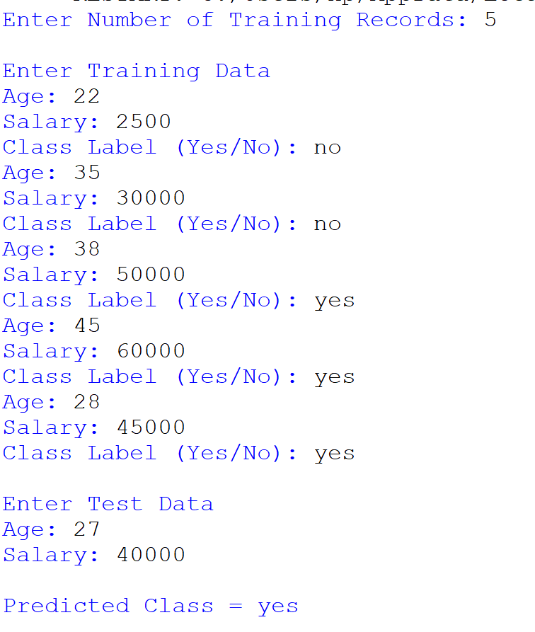

Result:
Thus, the Decision Tree Algorithm was implemented successfully, and the class label for the given test data was predicted correctly.

